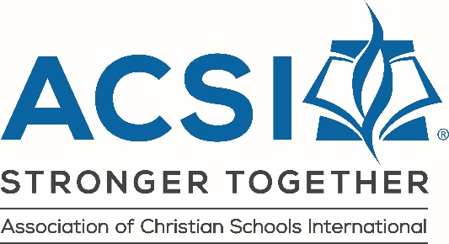

PROCESS FOR APPLYING FOR FLORIDA APPROVAL PROGRAM
EARLY EDUCATION/AFTER CARE PROGRAMS (NEW OR RENEWAL)

Complete this checklist and submit online with other required documents with your 2021-2022 Online Program Approval Application. Questions: Email acsi_east@acsi.org or contact Mame McMillan at 770.985.5840, ext. 4.

Program Name: _______________________________ Date: ___________________________

Program Renewal: Your current approval certificate expires on September 30, 2021. The Department of Children and Families will be notified on October 1, 2021 of schools that have not renewed.

Currently approved programs renewing on or before August 17, 2021….…………………………….$450
Currently approved programs renewing on August 18 or afterwards (late fee)…..………….………..$550

New Programs: Once you submit these documents and $500 fee, preferably two months prior to your scheduled opening date, your program will be pre-inspected in light of ACSI approval standards.
============================================================================
1 □ 2021-2022 ACSI Membership Renewal (June 2021 emailed invoice can be paid online) or
2021-2022 ACSI Membership Application (New programs: Visit acsi.org and click on “Join” to apply for membership.)
2 □ 2021-2022 Approval Program Online Application and fee (credit card payment only)
This online application is submitted with a separate fee.
3 □ ACSI Florida Approval Program Standards Affirmation of compliance with these standards
is by digital signature on online application (#2 above)

Submit the following documents separately with the online Approval Application:
4 □ 2021–2022 Staffing Form
5 □ Calendar (Schedule of school holidays and breaks)

Upload the following documents separately or as one scan together (in order shown below) with the online Approval Application:
6 □ Checklist – This document showing all requirements are being met toward program approval.
7 □ Letter from Pastor of Verification of Church Affiliation (notarized)
8 □ Director Credential
9 □ Childcare Attestation of Good Moral Character (Director only)
10 □ Certificate of Liability Insurance
(The address included at bottom left of form should be “Association of Christian Schools International, 731 Chapel Hills Drive, Colorado Springs, CO 80920” This is a new address to be updated on this year’s insurance form with renewal.) This insurance should include a minimum of $1 million in liability coverage as well as sexual abuse limits of not less than $250,000 per occurrence and Director’s and Officer’s Coverage. Student accident insurance is strongly encouraged for all students.)
11 □ Fire Marshal’s Inspection Report – valid within the last 12 months
12 □ Fire Drill/Emergency Preparedness Chart for last 12 months

