Award CEU's for ConNEXUS Premium courses viewed together as a faculty
*Please note that only those faculty members subscribed to ConNEXUS Premium are eligible to receive CEU credit for ConNEXUS Premium courses earned as a group.
Here's how....
Step one:
For Administrators: When you have determined who your Coaches will be. Go to your account page and change the “VPP Coach” box to “Yes”. Save. The Coach that you just assigned must log into their account and go to “Learning” for this change to be completed and for them to see their “Coach” tab in the Learning Community.
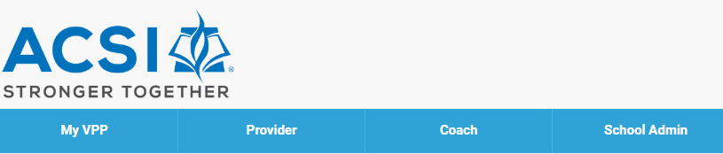

Step two:
Teachers: The teacher must assign their Coach to themselves. They do this from their VPP. Scroll to the bottom of their Practitioner VPP page and click on “Update Coach”.
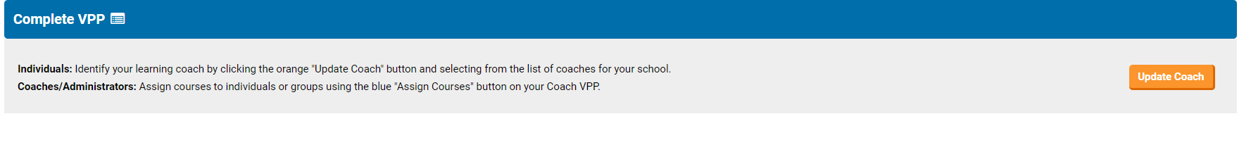
The teacher must type the name of their Coach in the “Coach” box. When the Coach name appears “Save”. The Coach and the teacher are now connected.

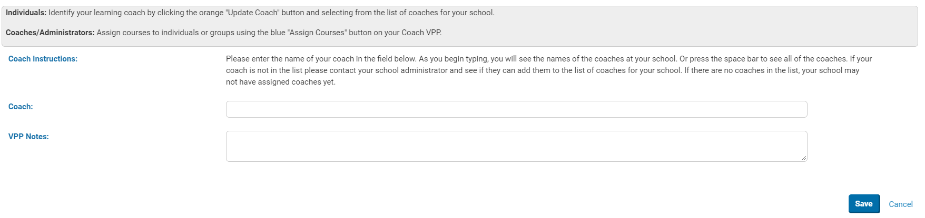

Step three:
For Coaches: From your “Coach” tab click on the orange “Search” tab. This will show you who has assigned you as their Coach.

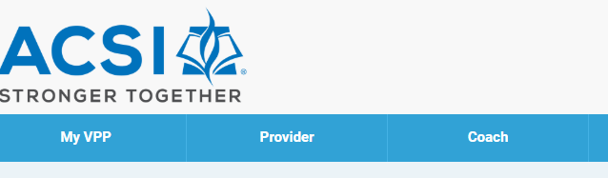
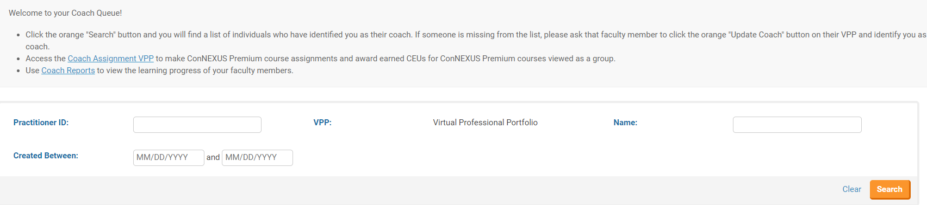

Click on the practitioners VPP (the blue “View” tab) next to their name.

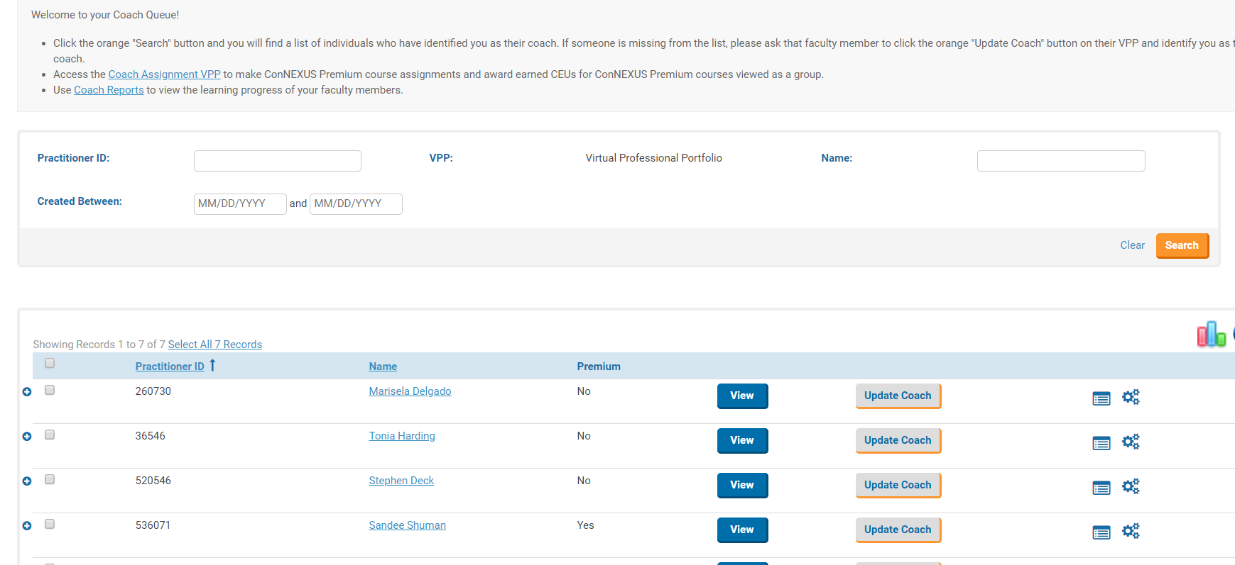

You are now in that practitioner’s VPP. Click on the “Go to Premium Courses”
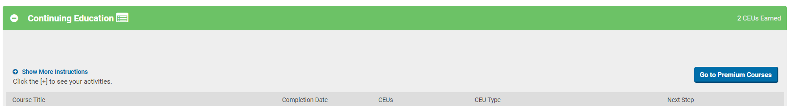

Choose the course you want to assign to that practitioner.
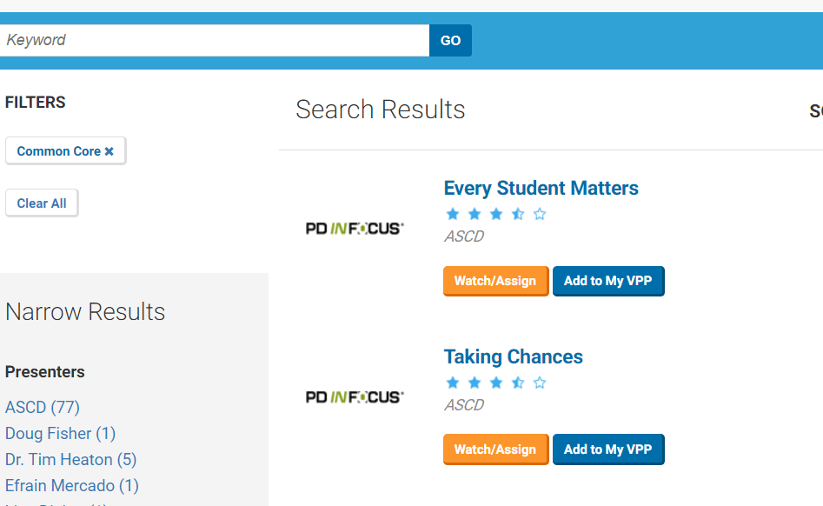

Assign a due date. You may want to be notified upon completion and you may want to add comments. Save to VPP.
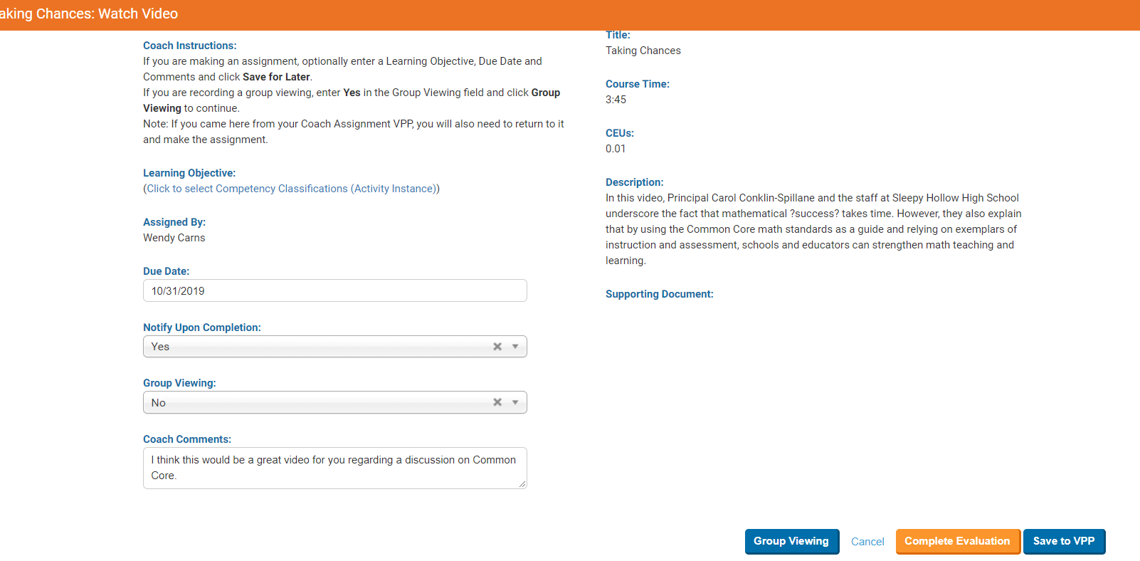

Step four: For the Practitioner - At this point the practitioner is ready to view the video. When they have completed the viewing, they must complete the evaluation and record the CEUs.

Launch and video.
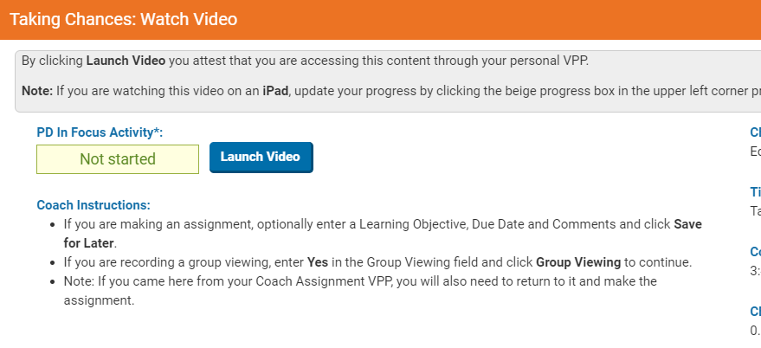
When the viewing has been completed, the viewer must complete the course evaluation and record
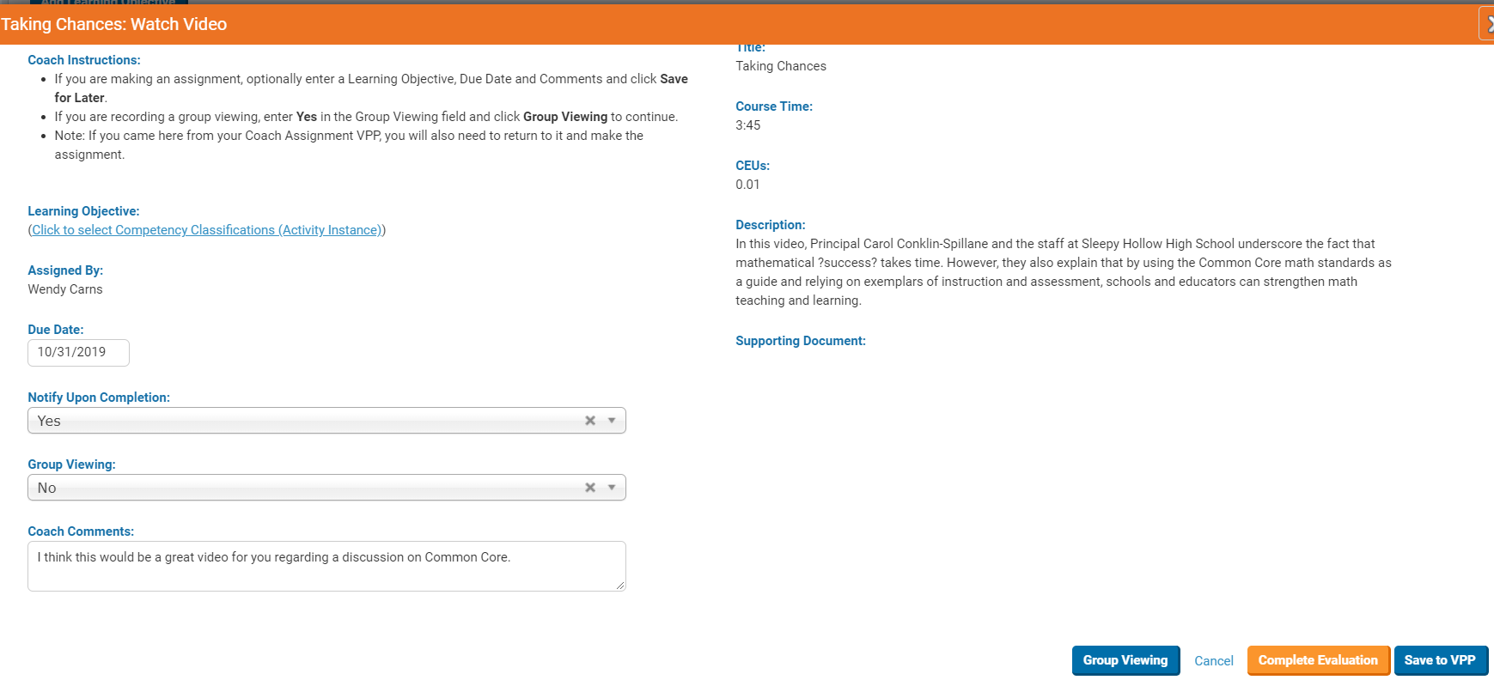

Complete Evaluation and “Record Activity”.
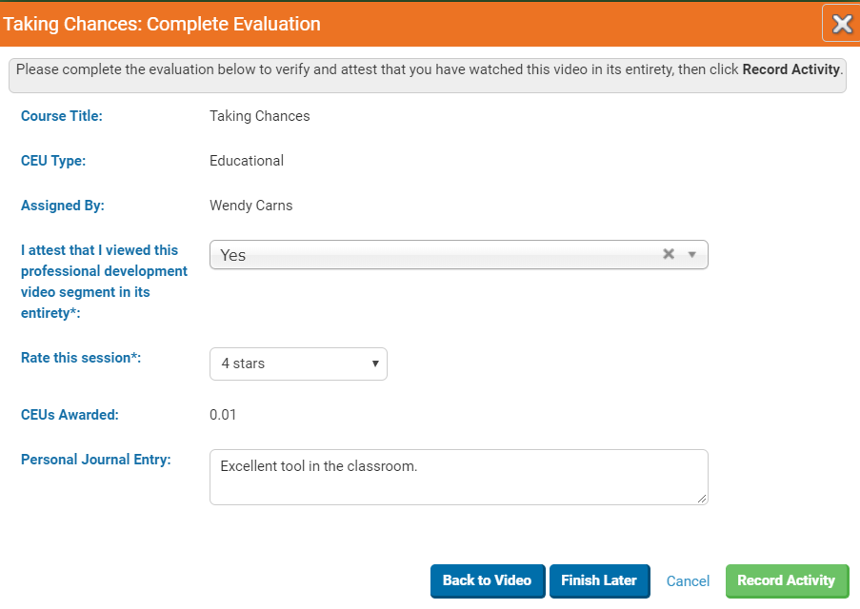

The CEUs have now been earned.
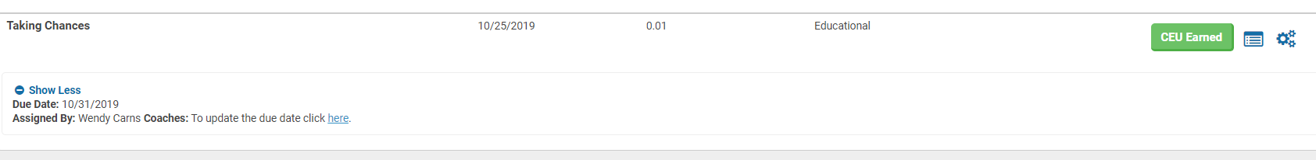

The End

Click on “Assign Courses”

Click on the people that you wish to assign a course to. You can request that an email be sent to the practitioners about the course assignment by clicking the “Send Email” box below. Then click on the orange “Assign” tab.

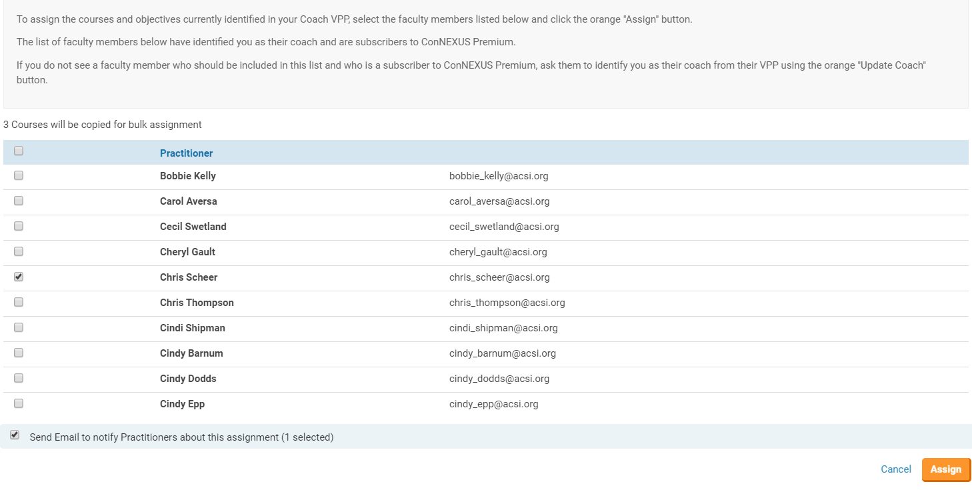

Now you will need to add courses: Click on the blue "ConNEXUS Premium Courses" button to navigate to ConNEXUS Premium. Select a course from ConNEXUS Premium and click the green "Watch/Assign" button.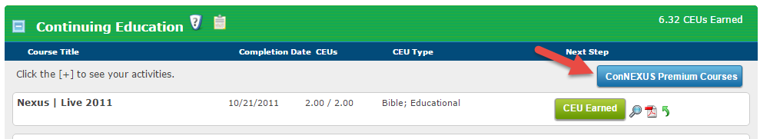
Choose your “Channel” and the course you wish to assign within that channel.
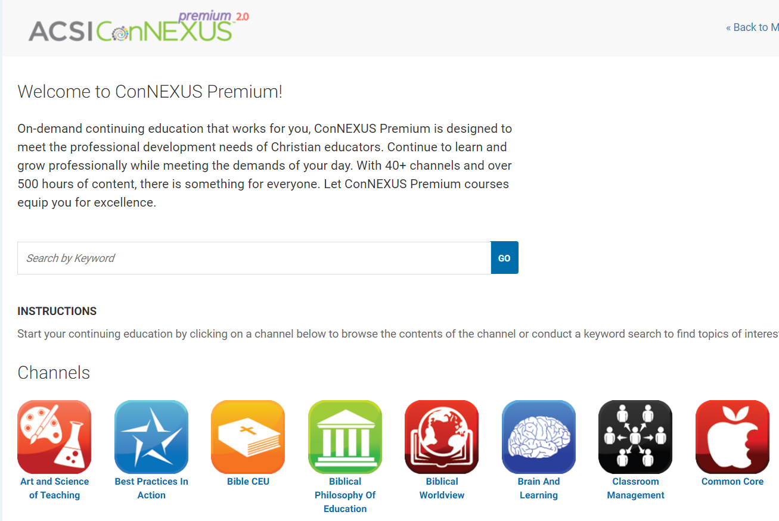

Click on the orange “Watch/Assign” tab

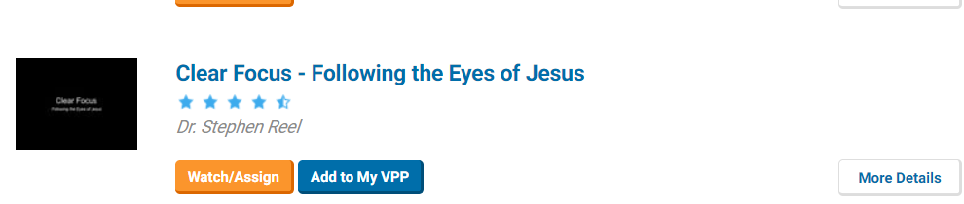

Say “Yes” to Group Viewing and click on the “Group Viewing” tab below. If you want to assign a “Due Date”, you can do that as well.
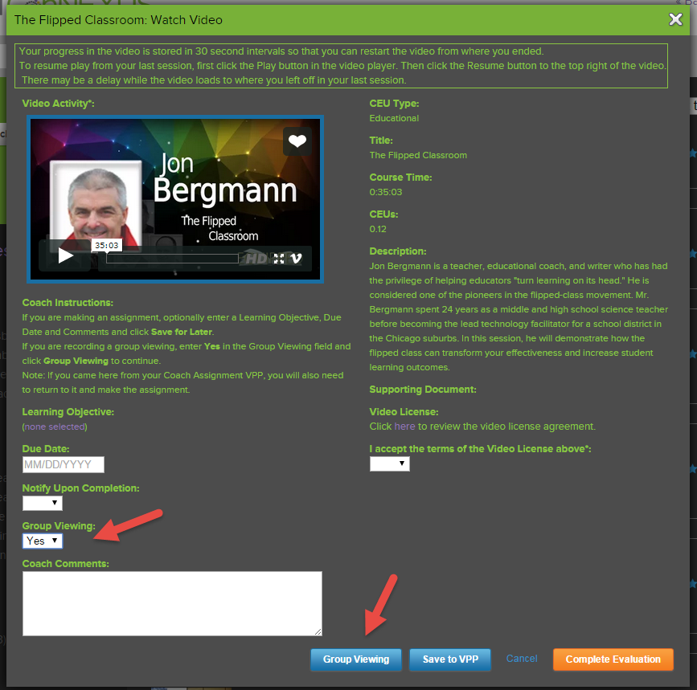

Now click on the orange “Record Course” tab.
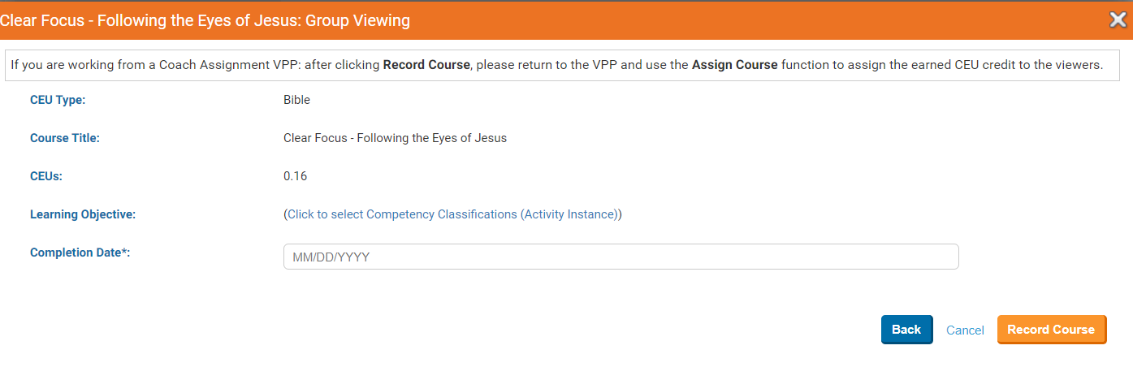

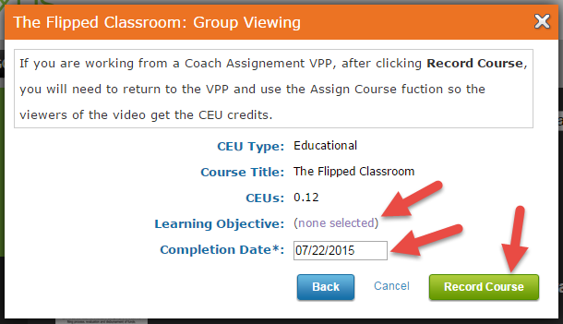

A Group Viewing box will open, in this box enter the date the CEU was earned, you may also identify a learning objective for the CEU (optional). Now click the green "Record Course" button.

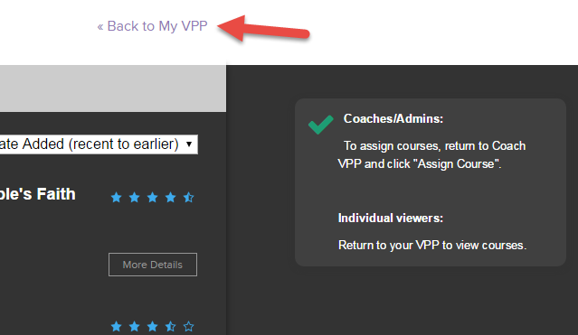

Click the "Back to My VPP" button to return to the Coach Assignment VPP.

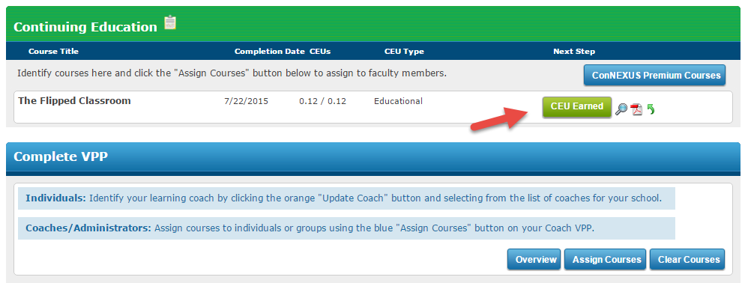

Notice that the course appears on the VPP with a green "CEU Earned" icon next to it.
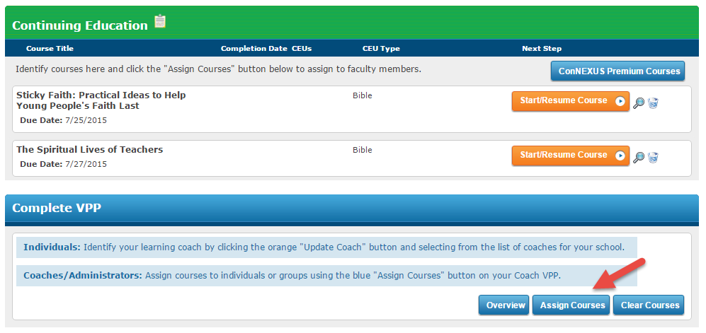

Now click the blue "Assign Courses" button at the bottom of the VPP to award the CEU to your faculty members.

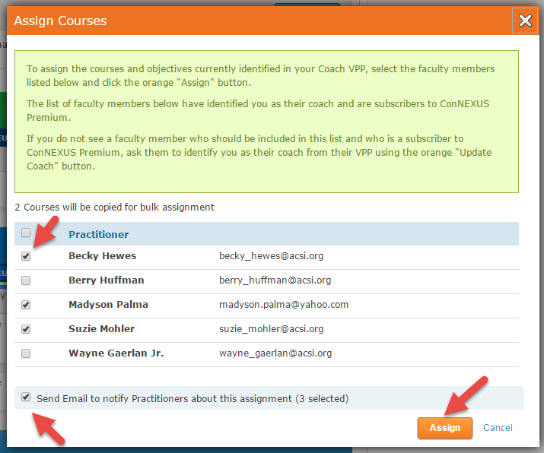

Identify the faculty members to whom you wish to award the CEU and click the orange "Assign" button.
You will receive a confirmation of the CEUs being awarded to each of your faculty members!
